
Wolkite University COLLEGE OF COMPUTING AND INFORMATICS
DEPARTMENT: Information system
COURSE TITLE: Advanced database
Project title: APARTAMENT RENTAL MANAGEMENT SYSTEM for WEFENCHA
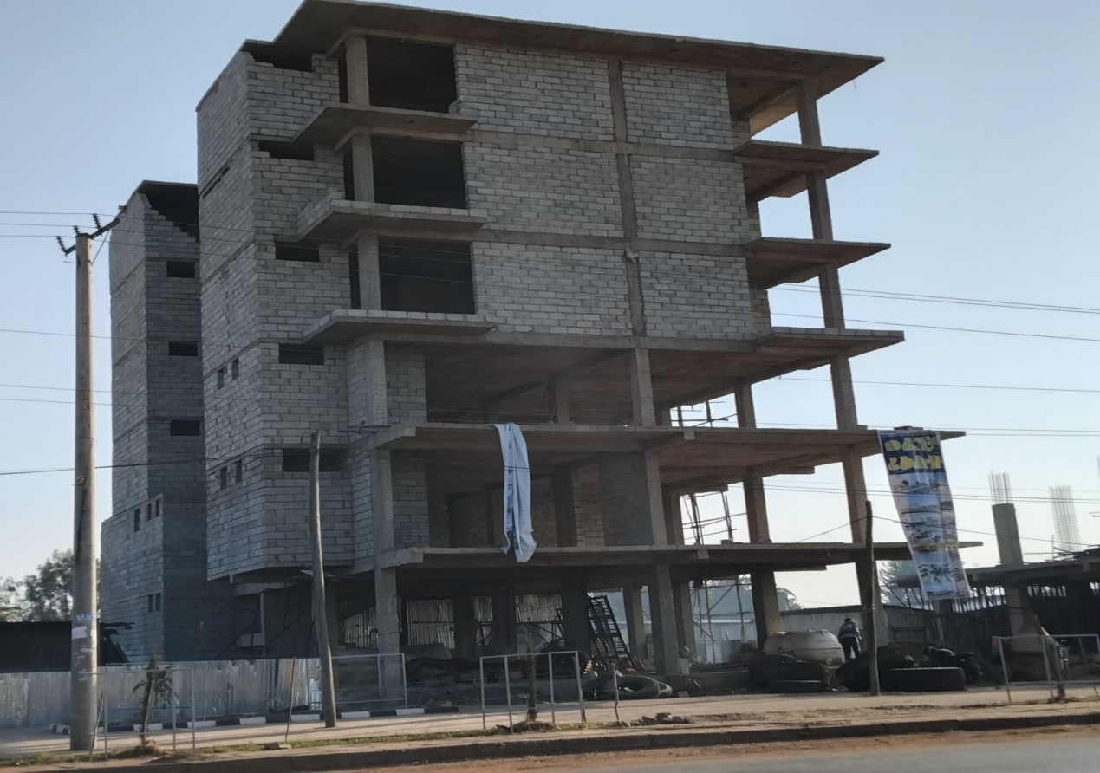
Team Members: ID NO
1. DAGMAWIT MEKONNEN ………………………………NSR/0218/16
2 . MEAZ TILAHUN ………………………………………….NSR/0533/16
- ELHAM ABDU…………………………………………………NSR/0267/16

TABLE OF CONTENTS
- Introduction
1.1 Background .................................................... …3
1.2 Problem Statement ............................................. 4
1.3 Project Objectives ..........................................… 4
1.3.1 General Objective ..................................... …4
1.3.2 Specific Objectives .................................... ..5
1.4 project metdology ........................................... 5
- System Design
2.1 ER Diagram ..................................................…. .6
2.2 Main entities and Attributes with Logical Schema….7
2.3 Table and Their Relationships ......................................10
- Implementation
3.1 Tools and Technologies Used ...........................…10
4.Testing and Results .............................................…13
4.1 Fundamental DB Concept ...........................................…11
4.2 Advanced DB Concept...................................................... ……..15
- Conclusion ........................................................ … 18
6,References ........................................................ . 19

🎯1 Introduction
1.1 Brief background
The apartment rental database is currently being developed due to the increasing population and the increasing demand for housing, as well as the imbalance between the land holdings and the population of the country, which is causing the construction of apartments or condominiums.
As a result, in most of our country's major cities and regional cities, due to the increasing development of commercial buildings, most commercial shops and serviced residences are being demolished and converted into apartments. Therefore, we have found a digital database system necessary.
Therefore, the digital database system we are working on WEFNCHA apartment system is a project for the construction of a digital database system, which is 80% complete and will soon be put into service. Therefore, when it comes into operation,Traditional manual methods—such as paper files or basic spreadsheets—often lead to errors, data duplication, delays, and difficulty in retrieving information. To solve these challenges, a centralized database system is developed.
The Apartment Rental System DB provides a structured way to store essential data such as apartment details, room types, rental prices, tenant information, maintenance requests, and payment history. It ensures data accuracy, supports quick retrieval, and streamlines operations like assigning tenants to apartments, generating reports, and tracking vacant or occupied units.
Overall, this digital database system for WEFNCHA apartment rentals that we are working on will speed up the process. It will also increase the trust between the landlord or property manager and the tenants. It will help us to permanently store the tenants' information and easily update it if necessary.

1.2 problem statment
The Apartment Rental Management System addresses several critical challenges in traditional property management at Wefencha Apartment. Currently, there is significant difficulty in tracking apartment availability due to the lack of real-time information on vacant, reserved, or occupied units, leading to double-booking when multiple agents reserve the same apartment without centralized updates. Manual recod-keeping using paper-based or spreadsheet methods is error-prone, resulting in mistakes, missing data, and inconsistent information scattered across notebooks, files, or computers. This lack of centralized data storage also makes it hard to manage tenant profiles, rental histories, and contact details effectively. Tenants receive inaccurate or outdated information about availability, prices, and apartment details, while the overall rental process remains slow and inefficient, requiring excessive time for phone calls and manual searches. Additionally, communication between owners and tenants is inefficient, with no structured system for notifications, updates, or feedback.
1.3Project Objectives
1.3.1 General Objectives
The Apartment Rental Management System for Wefencha Apartment is designed to modernize and streamline property Management by replacing traditional manual processes with a centralized, efficient relational database. The primary goal is to Enhance overall operational efficiency, minimize errors associated With paper-based or spreadsheet methods, ensure data accuracy and consistency, facilitate real-time information access, and foster greater trust and transparency between property managers and tenants through reliable digital record-keeping and management.
1.3.2 Specific Objectives
The specific objectives of the Apartment Rental Management System for Wefencha Apartment include storing and managing detailed apartment information—such as location, size, room type, floor number, building name, room number, and rent price—to enable real-time tracking of availability and prevent double-booking; securely recording and maintaining comprehensive tenant profiles, including name, phone, email, address, emergency contact details, and rental history for easy retrieval and updates; efficiently handling lease agreements by linking tenants to specific apartments while tracking start and end dates and recording monthly rent amounts; monitoring rent payments, encompassing due dates, payment amounts, dates, methods, and status (paid/unpaid), to facilitate timely financial tracking and reporting; and providing quick and accurate access to occupancy status, vacant units, and overall apartment availability for both staff and potential tenants.

1.4 project methdology
The project followed a structured database design approach. It started with requirements analysis and ER modeling to define entities and their one-to-many relationships. A logical schema was created with proper data types, primary/foreign keys, and constraints. SQL was used for implementation, including UPDATE for changes, DELETE for removals, ALTER for schema modifications , and SELECT with joins for queries. The focus was on data integrity, scalability, and best practices in relational databases.
1.5 project result
The system delivered a functional relational database for Wefencha Apartment, improving over manual methods with better accuracy and speed. The normalized schema eliminates duplication and supports real-time tracking of availability, occupancy, and payments via foreign keys. SQL operations enable easy updates, deletions, schema changes, and multi-table queries. Results show reduced errors, faster rental processes, transparent financial tracking, and reliable tenant records. The prototype is scalable for future features to an efficient digital solution..

🎯 2,System Design
2.1 Er Diagram

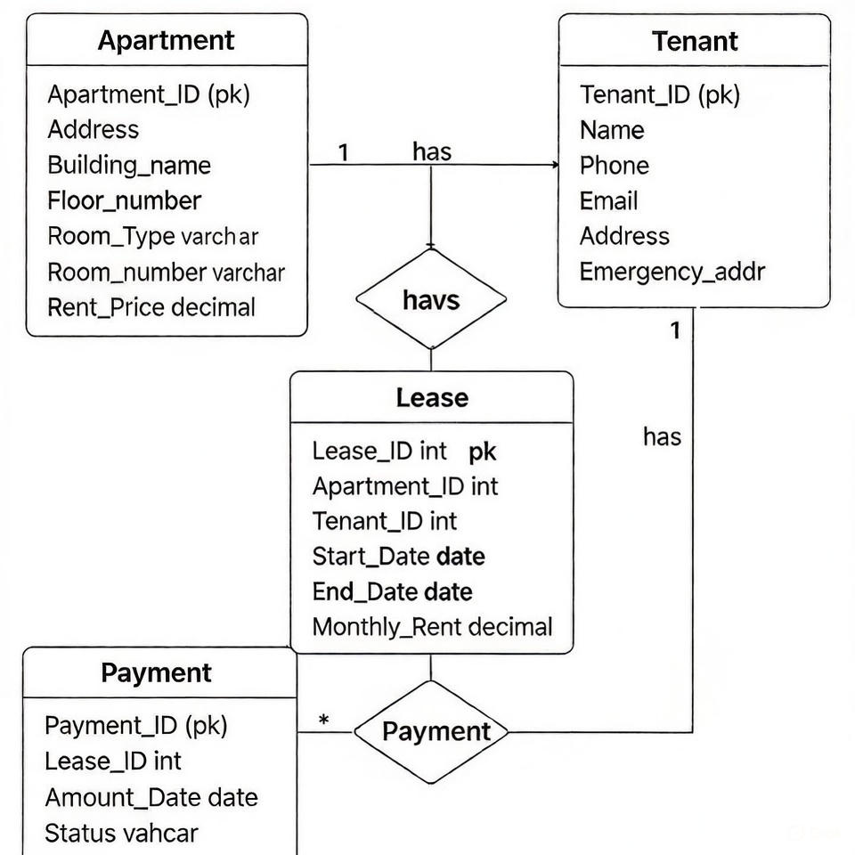

2.2Main Entities and Attributes with Logical schema
Table name:Apartment
Field name | Data type | Field Size | Constraint | Validation
Apartment_id | int | - | Primary Key | Not null
Address | varchar | - | - | Not null
Buliding_name | varchar | 20 | - | Not null
Floor_number | int | - | - | Not null
Room_number | int | - | - | Not null
Room_type | varchar | 30 | - | Not null
Rent_price | decimal | (10,2) | - | Not null

Table name:Tenant
Field name | Data type | Field Size | Constraint | Validation
Tenant_id | int | - | Primary Key | Not null
First_name | varchar | 50 | - | Not null
Last_name | varchar | 50 | - | Not null
Phone | varchar | 20 | - | Not null
Email | varchar | 20 | -
Address | varchar | 100 | - | Not null
Emergency_  address | varchar | 150 | - | Not null

Table name:Lease
Field name | Data type | Field Size | Constraint | Validation
lease_id | int | - | Primary Key | Not null
apartment_id | int | - | Foreign Key | Not null
tenant_id | int | - | Foreign Key | Not null
Start_date | date | - | - | Not null
End_date | date | - | - | Not null
Monthly_rent | decimal | - | - | Not null

Table name:Payment
Field name | Data type | Field Size | Constraint | Validation
Payment_id | int | - | Primary Key | Not null
Lease_id | int | - | Foreign Key | Not null
Payment_date | date | - | - | Not null
Amount | decimal | (10,2) | - | Not null
Payment_method | varchar | (30) | -
Status | varchar | (20) | -

2.3 RELATIONSHIP:
- Apartment → Lease:
- One apartment can have many leases over time (1-to-many).
Apartment.Apartment_ID = Lease.Apartment_ID
- Tenant → Lease:
- One tenant can have many leases (if they rent different apartments).
Tenant.Tenant_ID = Lease.Tenant_ID
- Lease → Payment:
- One lease can have many payments (monthly rent).
Lease.Lease_ID = Payment.Lease_ID
🎯 3,IMPLEMENTATION
3.1Tools and Tehnologies Used
- Database:mysql
- Query language :sql
- For interface:php,html,css
- For database connectivity:XAMPP
🎯 4,Testing and Resultss
From fundamental database concept (insert, alter ,drop ,update ,delet)
Insert value in apartment
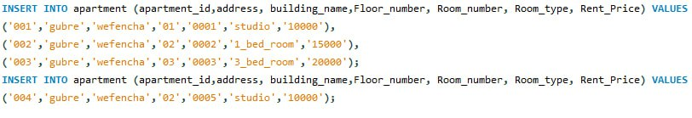
Insert value in tenant
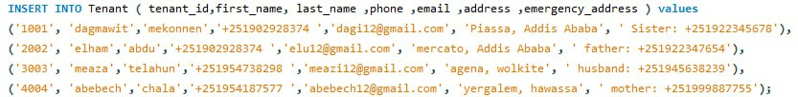
Insert value in lease
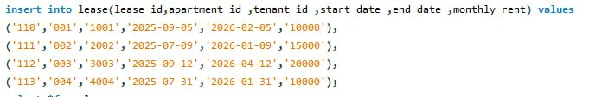
Insert value in payment
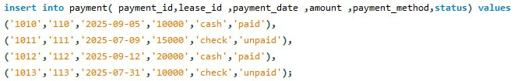

Select apartment
select*from Apartment;
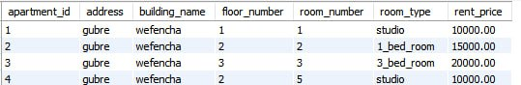
Select Tenant
select*from tenant;
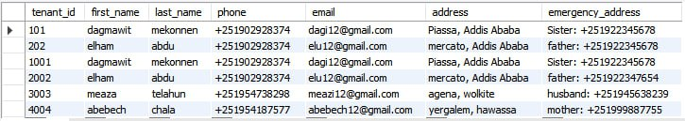
Select lease
select*from lease;
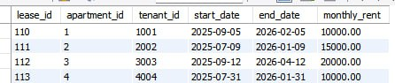
Select Payment
select*from payment;
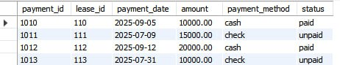
Alter value
ALTER TABLE tenant
ADD emergency_address varchar;
select*from tenant ;
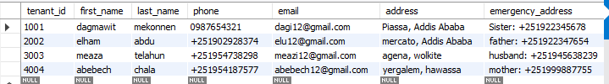

Update apartment rent price
UPDATE Apartment
SET Rent_Price = 13000
WHERE Apartment_ID ='001' ;
select*from apartment;
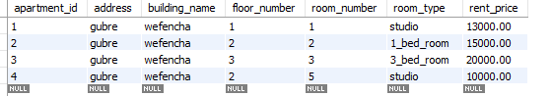

Delete a payment record
DELETE FROM Payment
WHERE Payment_ID ='1010' ;
select*from payment;
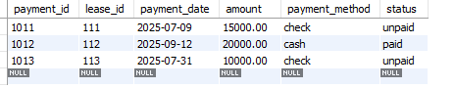

Delete a tenant
DELETE FROM Tenant
WHERE Tenant_ID ='2002' ;
select*from tenant;
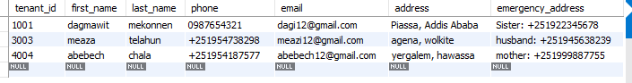
Add a new column to Apartment table
ALTER TABLE Apartment
ADD Number_of_Bathrooms INT;
select*from Apartment_Info;

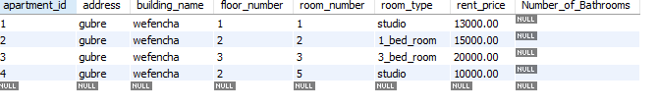
Drop a column
ALTER TABLE Tenant
DROP COLUMN emergency_address;

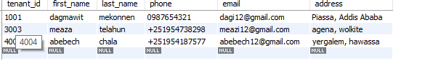

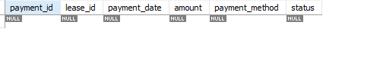
Rename Apartment table to Apartment_Info
select*from payment;
-- Rename Apartment table to Apartment_Info
ALTER TABLE Apartment RENAME TO Apartment_Info;
select*from Apartment_Info;
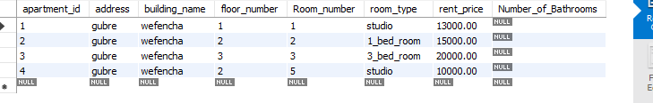

From advance database concepts (inner join, left join& right join , stored procedure & trigger ,concurrency control)
inner join
INNER JOIN lease l ON a.apartment_id = l.apartment_id
INNER JOIN tenant t ON l.tenant_id = t.tenant_id;
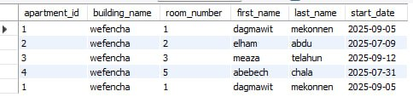

left join
LEFT JOIN lease l ON a.apartment_id = l.apartment_id
ORDER BY a.apartment_id;
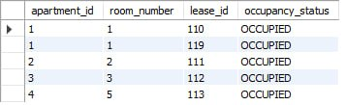

right join
RIGHT JOIN payment p ON l.lease_id = p.lease_id;
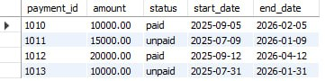

stored procedure
DELIMITER //
CREATE PROCEDURE GetApartmentOccupancyStatus()
BEGIN
SELECT
a.apartment_id,
a.room_number,
a.room_type,
a.rent_price,
l.lease_id,
CASE
WHEN l.lease_id IS NULL THEN 'VACANT'
ELSE 'OCCUPIED'
END AS occupancy_status
FROM apartment a
LEFT JOIN lease l ON a.apartment_id = l.apartment_id
ORDER BY a.apartment_id;
END //
DELIMITER ;
CALL GetApartmentOccupancyStatus();
Use this command to execute the procedure and see the output:
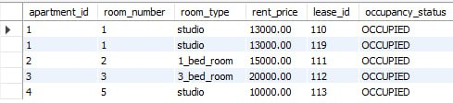

CREATE PROCEDURE GetTenantDetailsById (
IN p_tenant_id INT
)
BEGIN
SELECT
t.tenant_id,
t.first_name,
t.last_name,
t.phone,
t.email,
t.address AS tenant_address,
a.apartment_id,
a.building_name,
a.room_number,
a.room_type,
l.start_date,
l.end_date,
l.monthly_rent
FROM tenant t
LEFT JOIN lease l ON t.tenant_id = l.tenant_id
LEFT JOIN apartment a ON l.apartment_id = a.apartment_id
WHERE t.tenant_id = p_tenant_id;
END //
DELIMITER ;
CALL GetTenantDetailsById(1001);
Use this command Retrieves tenant information using tenant_id

Commit
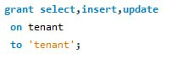
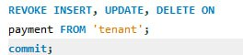
🎯 5,Conclusion
This Apartment Rental Management System for Wefencha Apartment successfully achieves its core objectives by delivering a robust, normalized relational database that replaces inefficient manual processes with a centralized digital solution, ensuring data accuracy, eliminating redundancy through well-defined entities (Apartment, Tenant, Lease, and Payment) and one-to-many relationships, and enabling real-time tracking of availability, occupancy, leases, and payments. The implementation effectively demonstrates proficiency in fundamental database operations (INSERT, UPDATE, DELETE, ALTER, DROP) for flexible data and schema management, as well as advanced concepts including INNER, LEFT, and RIGHT JOINs for complex querying, while laying a solid foundation for stored procedures, triggers, and concurrency control. As a result, the system significantly reduces errors, accelerates rental processes, enhances financial transparency, and builds greater trust between property managers and tenants, providing a scalable prototype ready for deployment in urban housing management.
For future improvements, the system can be enhanced by developing a user-friendly web or mobile application interface for easier access by managers and tenants, integrating automated notifications (e.g., payment reminders via email/SMS), adding reporting and analytics features for generating detailed occupancy and revenue reports, implementing user authentication and role-based access control for security, incorporating maintenance request tracking as a new entity, and supporting features like document uploads for contracts or photos of apartments to further streamline operations and user experience.

🎯 6,References
- Youtube
- lab manual
- lecture pdf
- oracle database

